9 SCIENCE INVESTIGATION 2015

EARTHQUAKES
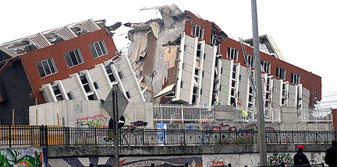
Name:_________________ Teacher:________________

Form:_________________ Due date: Mon 7th December

Aim: This investigation will help you learn how seismometers work and to see how the design and construction of buildings in earthquake prone areas allows them to withstand the movements.

Overview:

❶ Complete research section.
❷ Build a small model of a building.
❸ Build a second model of a building with a modification.
❹ Observe what happens to the first building model when earthquake is simulated.
❺ Observe what happens to second, modified building model when earthquake is simulated.

Guidelines:

Both buildings that you build can be as simple/complex as you wish but must not be larger than the size of a tissue box (21 x 9.5 x 11.5cm).

A seismograph will be available to use during your investigation.

IMPORTANT INFORMATION

Plagiarism

⬥ The experiment is to be done in your science group but your write-up and results are to be done individually.
⬥ Plagiarising = instant zero on assignment and you will have to re-do it.

Assessment policy

Have sick note/legitimate reason from parent = new negotiated due date.
Assignment not submitted on due date and no sick note from parents = -20% mark
Assignment not submitted on new negotiated due date = -40% mark
+ Letter home to parents
+ Must attend academic completion to complete assignment

If you are not at school on the day this assignment is due, it is still expected to be submitted electronically.

Research

1. Explain what a seismograph is used for.

_________________________________________________________________________________

_________________________________________________________________________________

_________________________________________________________________________________

_________________________________________________________________________________

_________________________________________________________________________________

2. Briefly describe how a seismograph works.

_________________________________________________________________________________

_________________________________________________________________________________

_________________________________________________________________________________

_________________________________________________________________________________

_________________________________________________________________________________

_________________________________________________________________________________

_________________________________________________________________________________

_________________________________________________________________________________

Extra notes on seismographs.

_________________________________________________________________________________

_________________________________________________________________________________

_________________________________________________________________________________

_________________________________________________________________________________

_________________________________________________________________________________

_________________________________________________________________________________

_________________________________________________________________________________

_________________________________________________________________________________

_________________________________________________________________________________

_________________________________________________________________________________

_________________________________________________________________________________

_________________________________________________________________________________
3. Describe two possible modifications made to buildings in earthquake-prone areas and explain how they reduce damage to the building.

Modification one: ____________________________________________________________________

_________________________________________________________________________________

_________________________________________________________________________________

_________________________________________________________________________________

_________________________________________________________________________________

_________________________________________________________________________________

_________________________________________________________________________________

Modification two: ____________________________________________________________________

_________________________________________________________________________________

_________________________________________________________________________________

_________________________________________________________________________________

_________________________________________________________________________________

_________________________________________________________________________________

_________________________________________________________________________________

Extra notes on earthquake-proof buildings.

_________________________________________________________________________________

_________________________________________________________________________________

_________________________________________________________________________________

_________________________________________________________________________________

_________________________________________________________________________________

_________________________________________________________________________________

_________________________________________________________________________________

_________________________________________________________________________________

_________________________________________________________________________________

_________________________________________________________________________________

_________________________________________________________________________________

_________________________________________________________________________________

_________________________________________________________________________________

How to reference

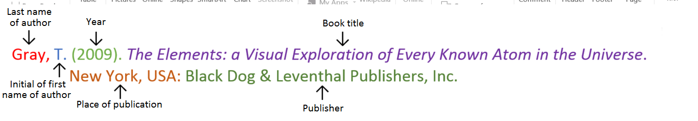
Book

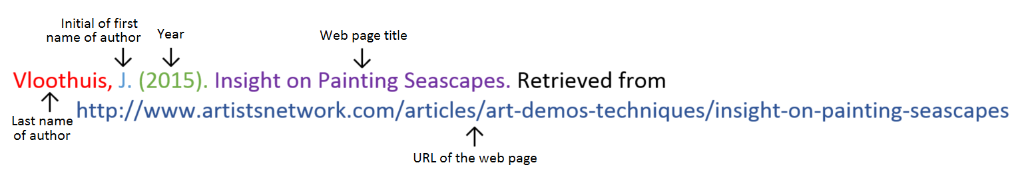
Website

Website with no author (put title of page at the front)

Aranmore Catholic College. (2014). Retrieved from http://www.aranmore.wa.edu.au/

Website with no date

The Zadkine Museum. (n.d). Retrieved http://www.france.fr/en/museums/zadkine-museum.html

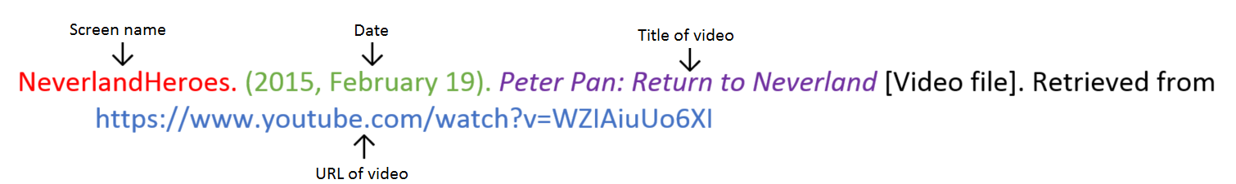
Video file

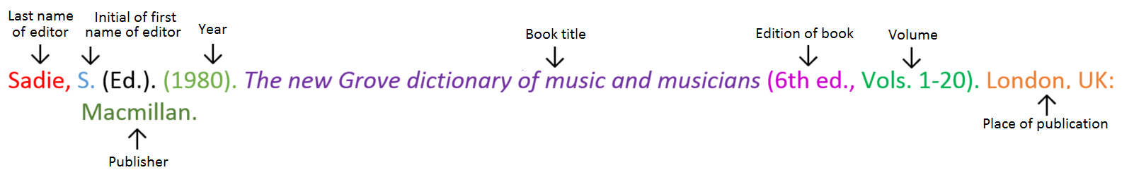
Encyclopaedia or dictionary

Reference page (minimum two references used for research information).

_________________________________________________________________________________

_________________________________________________________________________________

_________________________________________________________________________________

_________________________________________________________________________________

_________________________________________________________________________________

_________________________________________________________________________________

_________________________________________________________________________________

_________________________________________________________________________________

_________________________________________________________________________________

_________________________________________________________________________________

_________________________________________________________________________________

_________________________________________________________________________________

_________________________________________________________________________________

_________________________________________________________________________________

_________________________________________________________________________________

_________________________________________________________________________________

_________________________________________________________________________________

_________________________________________________________________________________

_________________________________________________________________________________

_________________________________________________________________________________

_________________________________________________________________________________

_________________________________________________________________________________

_________________________________________________________________________________

_________________________________________________________________________________

_________________________________________________________________________________

_________________________________________________________________________________

_________________________________________________________________________________

_________________________________________________________________________________

_________________________________________________________________________________

MARKING KEY

Content | Description |  | Your  mark
Research | Suitable answers to seismograph questions.  Suitable answers to building design questions.  Minimum of 2 references used.  Referenced in correct format. | 2  2  1  1
Materials | Is written in a list.  Includes all materials and amounts. | 1  1
Independent  variable | Listed the independent variable (what you changed). | 1
Dependent  variable | Listed the dependent variable (what you measured). | 1
Controlled  variables | Listed two controlled variables (what was kept the same for each trial). | 2
Explanation of  changes | Described modification made to building.  Explained why modification was chosen.  Labelled diagram or labelled photo of original building.  Labelled diagram or labelled photo of modified building. | 1  1  1  1
Buildings | Original building was constructed following guidelines.  Modified building was constructed following guidelines.21 | 1  1
Demonstration | Student participated in experimentation. | 1
Results | Label photos of both seismometer readings.  Explain seismometer readings (what happened at which points on the reading). | 1  1
Discussion | Describes two errors that occurred.  Explains how these errors may have affected the results.  Describe one change you would make to the experiment if it was to be repeated. | 2  2  2
Presentation | Correct spelling, grammar, scientific language used.  Subheadings are used and information is well presented. | 1
Total mark |  | 28

Mark as percentage %
Teacher’s comments:

________________________________________________________________________________________

________________________________________________________________________________________

________________________________________________________________________________________

________________________________________________________________________________________

